**MAIN HEADERS FOR WEBSITE:**

**HOME**

**ABOUT SDG CAMPUS CLUB**

**ABOUT SDGs**

**SDG INTERNATIONAL FILM FESTIVAL**

**WEBINARS AND EXPERT TALKS**

**PARTNERS**

**FAQ & CONTACT**

1. Home

**Put a demo photograph for now. (Landing Page)**

**Try Incorporating Footer – for the Home Page with contact details such as email id, address of NIT Rourkela etc.**

**Logo of SDG Campus Club –**

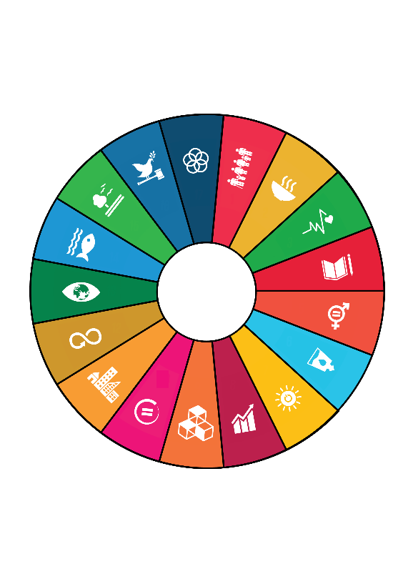

1. 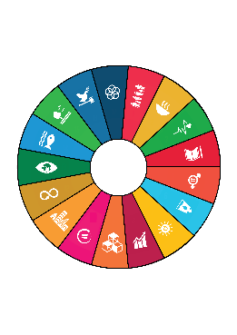About SDG Campus Club, NIT Rourkela

The inception of the SDG Campus Club was based on the theme of promoting the 17 Sustainable Development Goals of the United Nations and conducting events and seminars for raising awareness about them within the students and faculty. The SDGs encompass all aspects of societal development including – Environment Protection, alleviating poverty, promoting healthy lifestyle, Promoting Sustainable use of energy and maintaining proper hygiene, Women Empowerment, Education for all etc. and act as parameters for a developmental index. Being the first of its kind among the all other social service clubs on campus – this club would not just be limited to conducting direct events with NGOs and Governmental Organizations but also conducting conferences, seminars, marathons, awareness weeks, etc. in collaboration with other clubs under the society including of the likes conducted by the literary clubs.

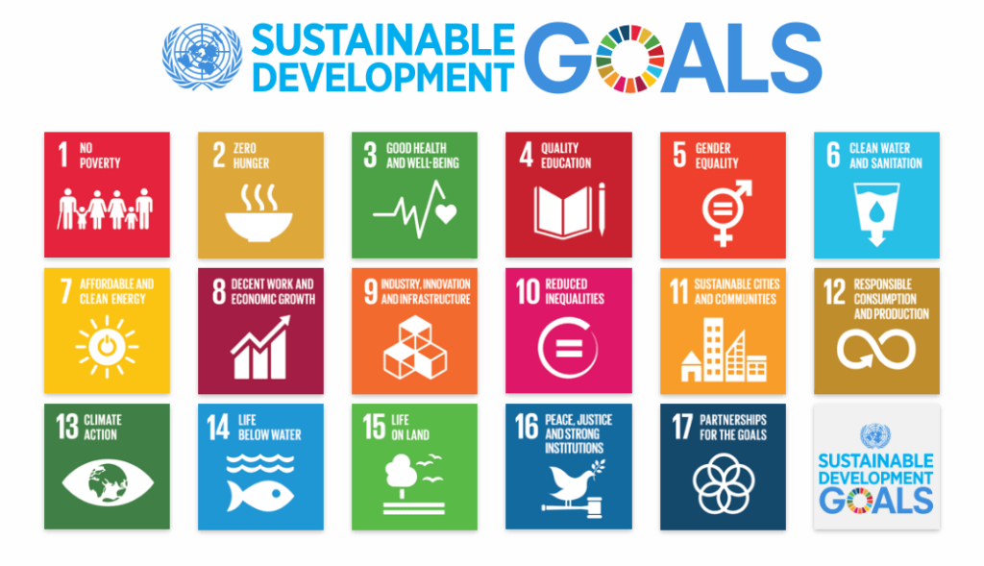

The Club is organizing the SDG International Film Festival of NIT Rourkela on 3rd and 4th of October. Please check the **International Film Festival** section for more details regarding the detailed itinerary including speakers and list of documentaries & short films to be screened in the festival.

1. About SDGs

The United Nations **Sustainable Development Goals** are the blueprint to achieve a better and more sustainable future for all.

Refer the Booklet on SDGs for Remaining Content in this section.

1. SDG International Film Festival

The SDG International Film Festival aims to bridge the gap between policy makers, civil society, non-profits and the youth. Through the 2-day festival which would involve **online screening of award-winning documentaries and short films** based on the various SDG thematic areas as well as **pre-conference talk series with various experts,** we hope to make it an enriching experience for both the participants and other stakeholders.

The screening of the short films shall also be followed by a **live interaction with the directors and actors of the documentaries who would provide a short keynote on the inspiration behind making the short film followed by a question and answer session with the audience.**

Short Films and Feature Documentaries

(To be screened at the Film Festival)

1. Create 2030
2. Sayang Kalimantan
3. Protecting Our Planet: Aquastory
4. Sustainable Futures: Survivor Girls
5. Mr. Toilet: The World’s #2 Man
6. The Conductor

Speakers & Guests

1. Lisa Russells
2. Wally Tham
3. Diana Henriques
4. Nicole Watson
5. Jack Sims
6. Bethany Borg
7. Webinars & Expert Talks

* Kehkashan Basu
* Sunil Murlidhar Shastri

**6)** Partners

**Event Sponsors**

Farm to Fork Solutions



**Event Partners**

Phoenix Events & Entertainment



**Partner Clubs & Student Bodies**

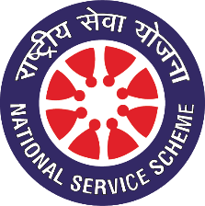

NSS NIT Rourkela

**7) FAQ & Contact**

FAQ (Take Inspiration from <https://nitrimun.org/FAQ.html>)

* What is the SDG International Virtual Film Festival all about and who is organizing it?

Ans.

* Who can participate and what are the dates of the Film Festival?

Ans.

* Is there a registration fee for attending the Film Festival? Also do I need to be a part of a college delegation to participate in the Film Festival?

Ans.

* What are the other benefits and perks of attending the Film Festival?

Ans.

* How to register for the Film Festival and take part?

Ans.

|  |
| --- |
| Reach out to us at:  MAKE A FORM (NAME, EMAIL ID, PHONE NUMBER, MESSAGE) |